DISNEY KINDERGARTEN AND PRIMARY SCHOOL.
NUMERACY HOLIDAY WORK - NURSERY CLASS.
Name: ______________________________________
Dear parent/guardian,
Is your child struggling with the pencil grip?
Worry not, here are some activities to help your child develop a firm grip.
- Manipulating small objects eg. Drawing, working out jig-saw puzzles, opening containers, threading, beading, washing utensils and clothes, pegging, pretend play etc.
- Finger games, pocking games eg. Five little monkeys, open shut them, itsy bitsy spider, paper-scissors-rock.
- Below are some videos with finger play songs and rhymes.
https://www.youtube.com/watch?v=PNaiU0jAgbI
https://www.youtube.com/watch?v=U9ey2k0Zis8
https://www.youtube.com/watch?v=S9XZX3m06cE&list=RDS9XZX3m06cE&start_radio=1
https://www.youtube.com/watch?v=XqZsoesa55w
https://www.youtube.com/watch?v=h4eueDYPTIg
https://www.youtube.com/watch?v=fHqjNHxmB7c – Numeracy
- Manipulative skills include; throwing, catching, kicking, rolling, dribbling, collecting or striking.
- Play materials like play dough, clay modeling and sand play
- Functional play which is a powerful tool for developing cognitive and social skills eg. Stacking cups, books, legos etc.

- Paper cutting and sticking, putting things together, taking them apart, sorting or molding.
I hope these are helpful.
Stay safe!
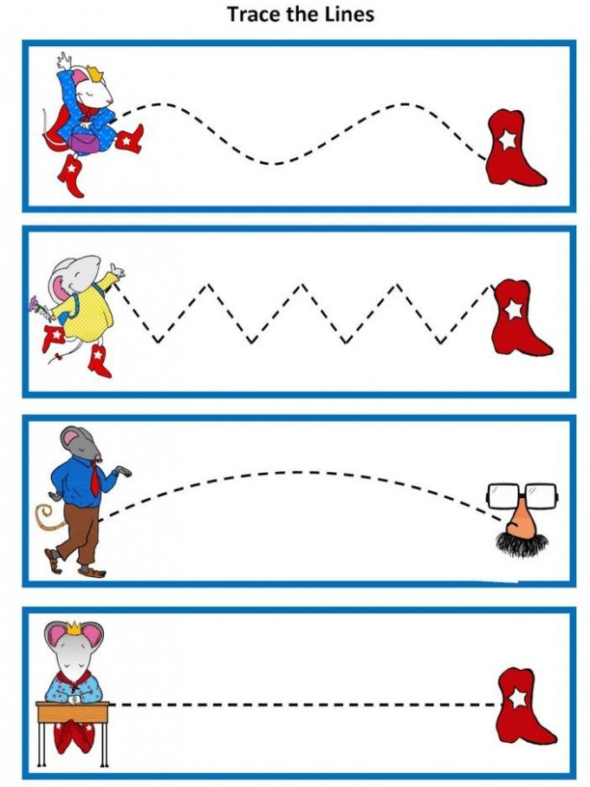
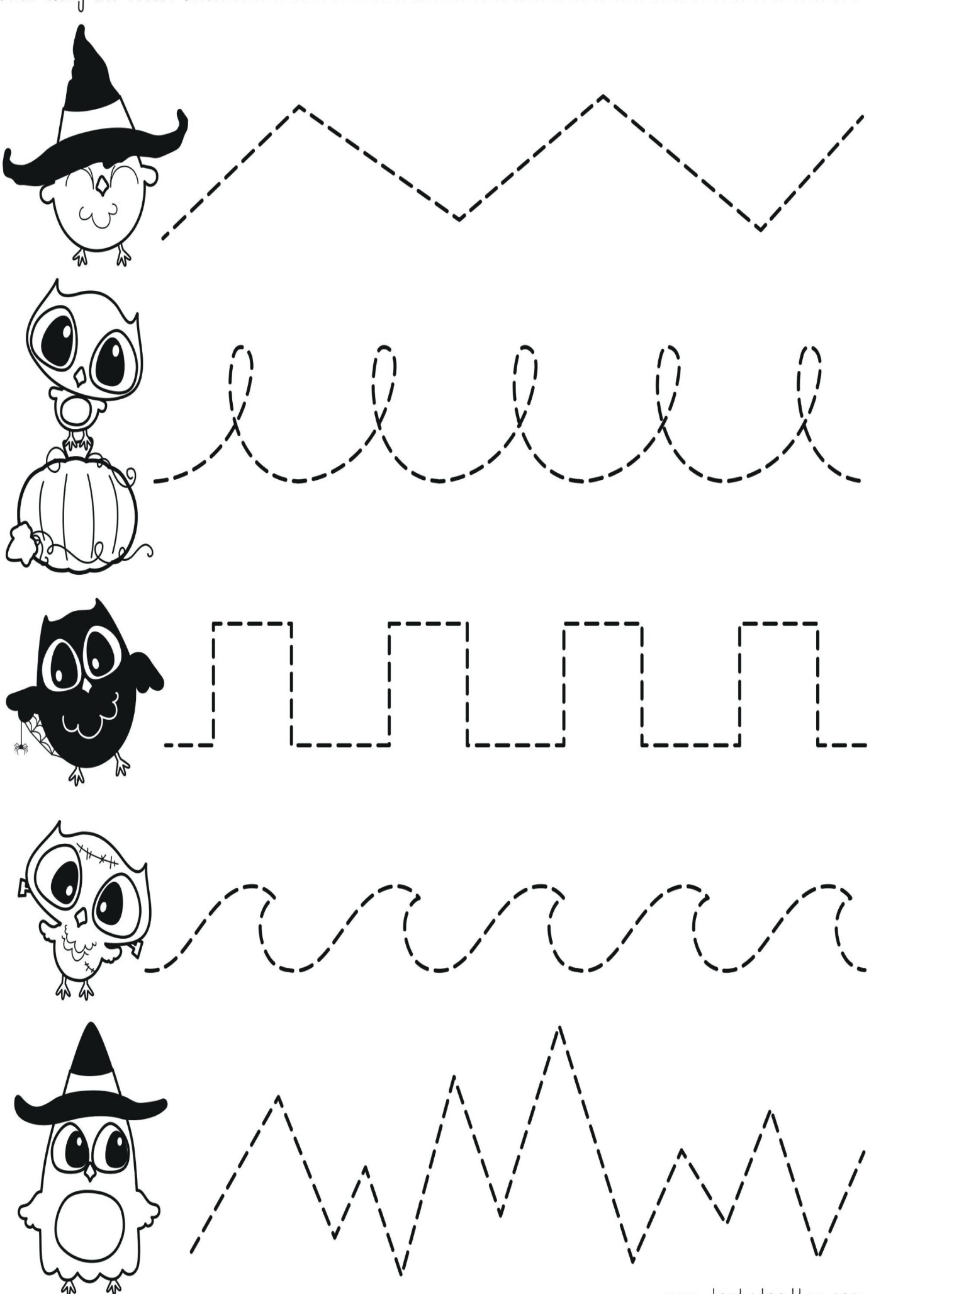

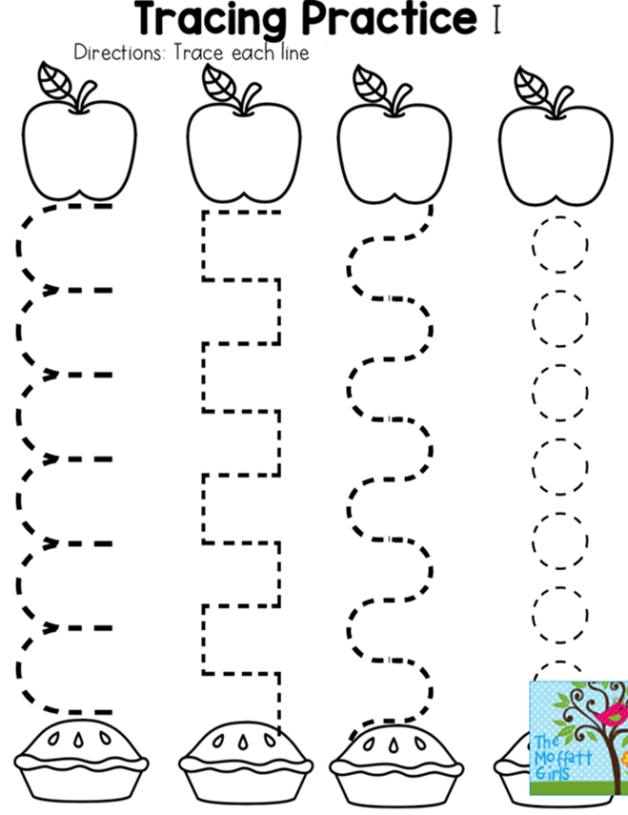

Practice tracing.
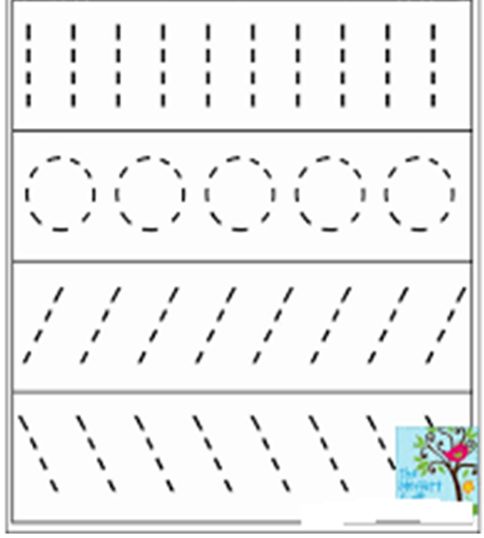

Join the dots to form a shape.
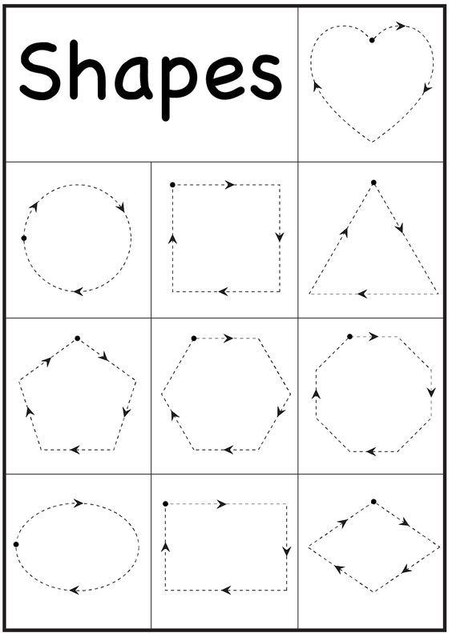

Say the number and colour the shapes.
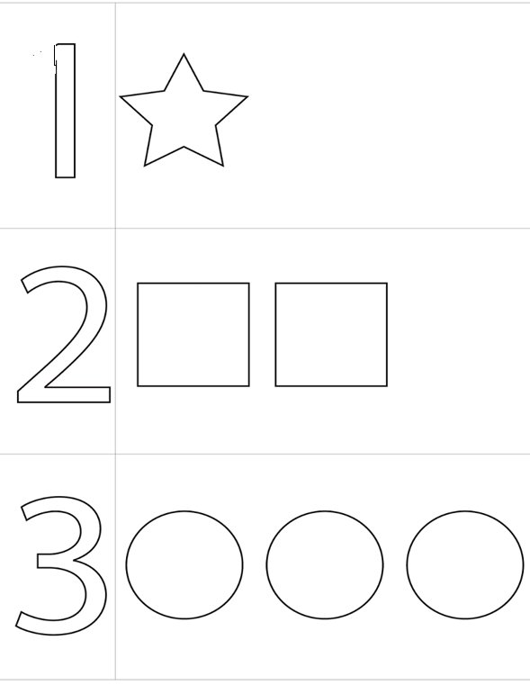

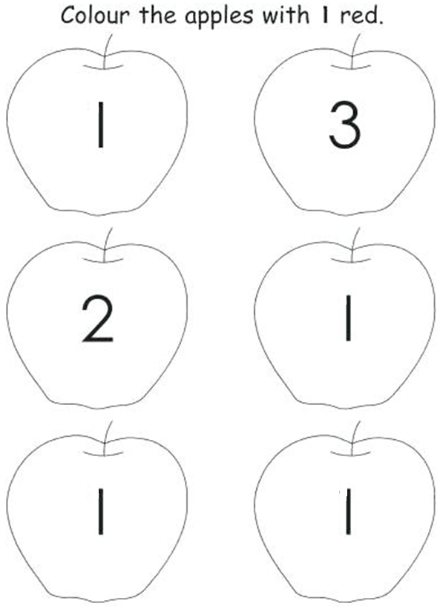

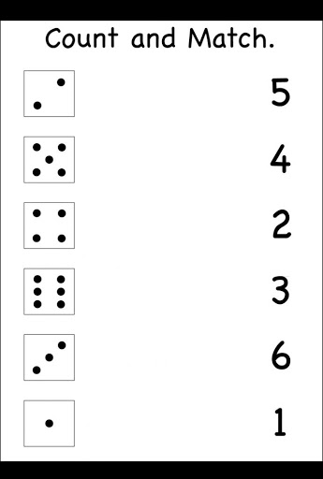

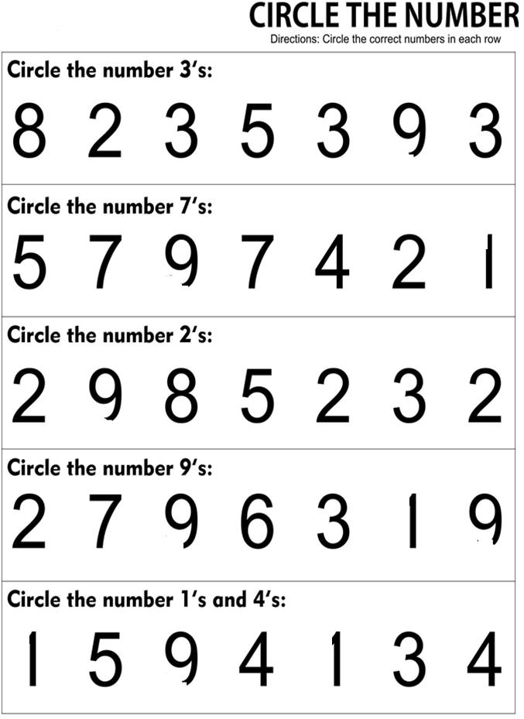
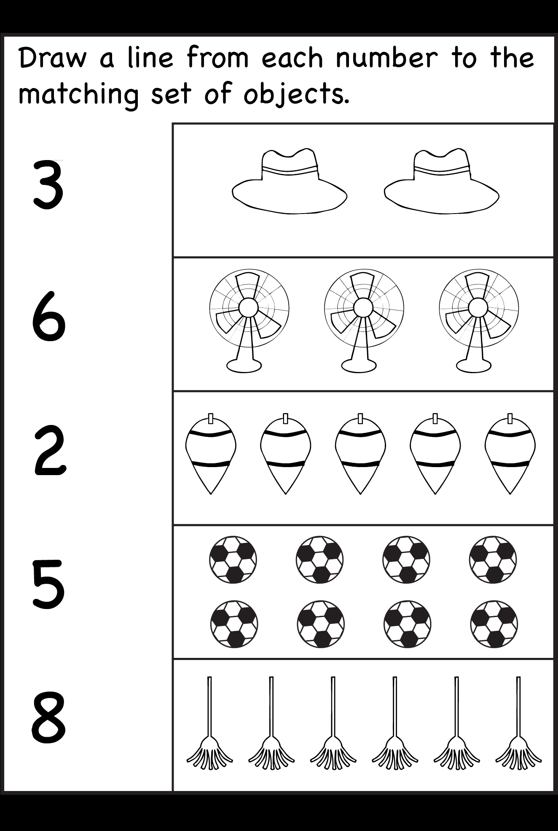

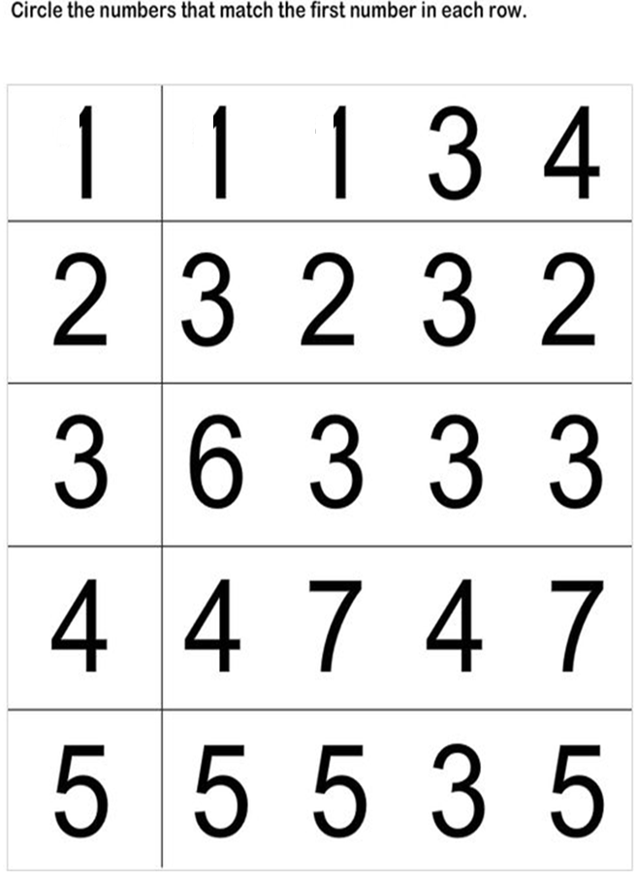

Count and match.
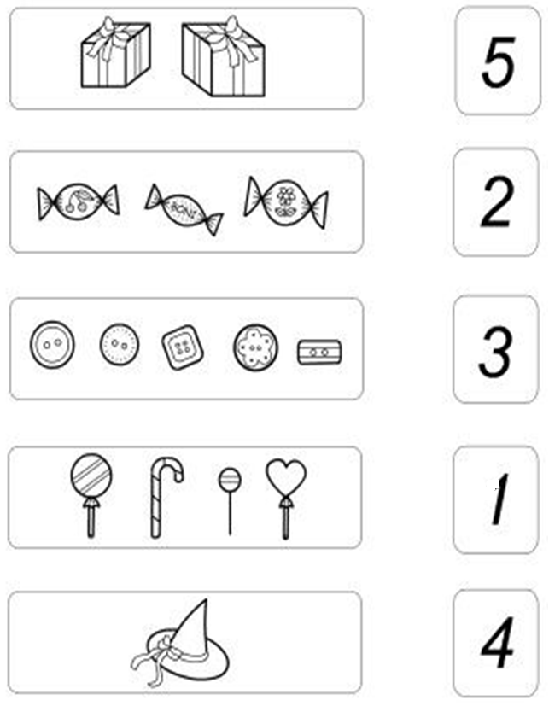
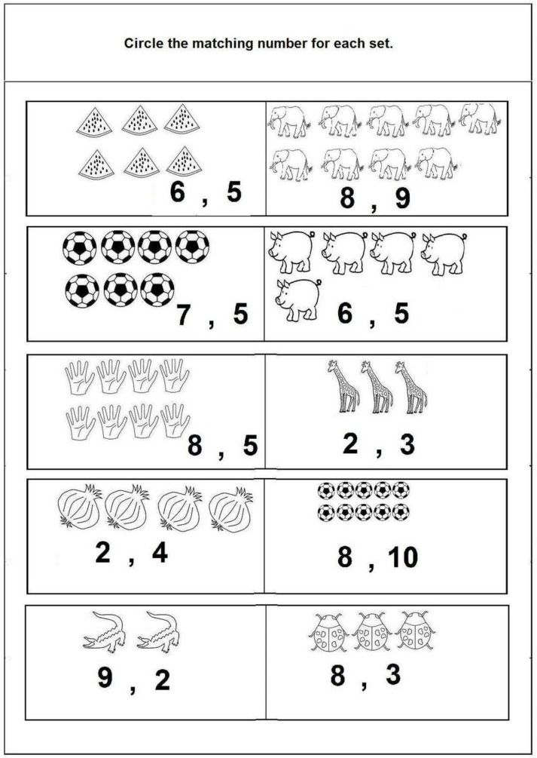
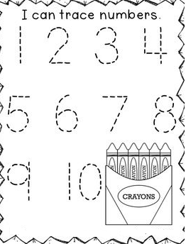

Join the dots to form the number.
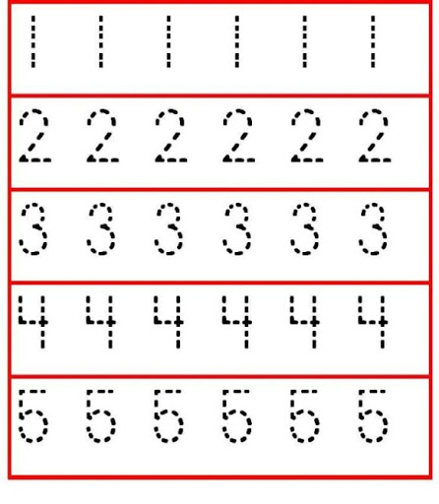

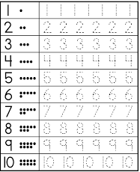
Form the number correctly.

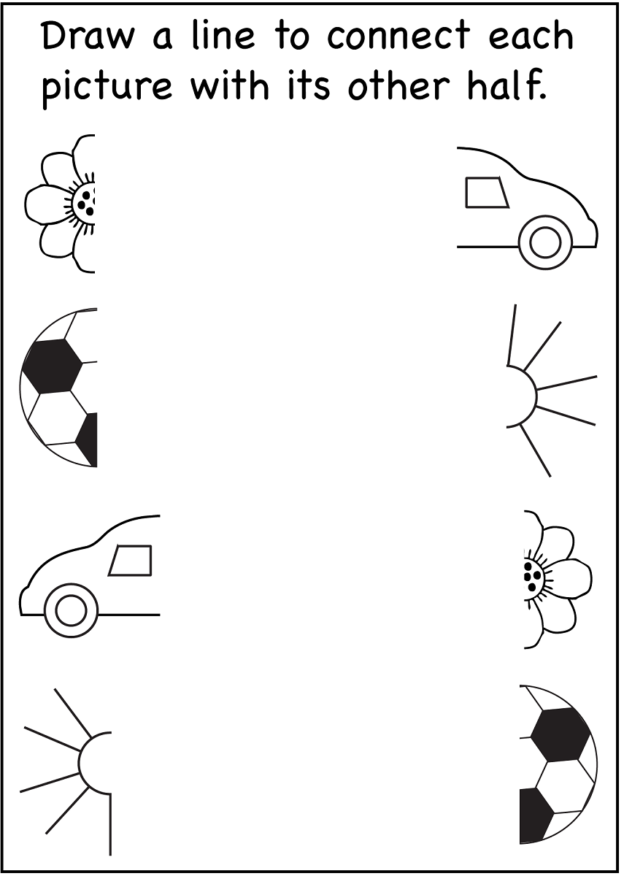

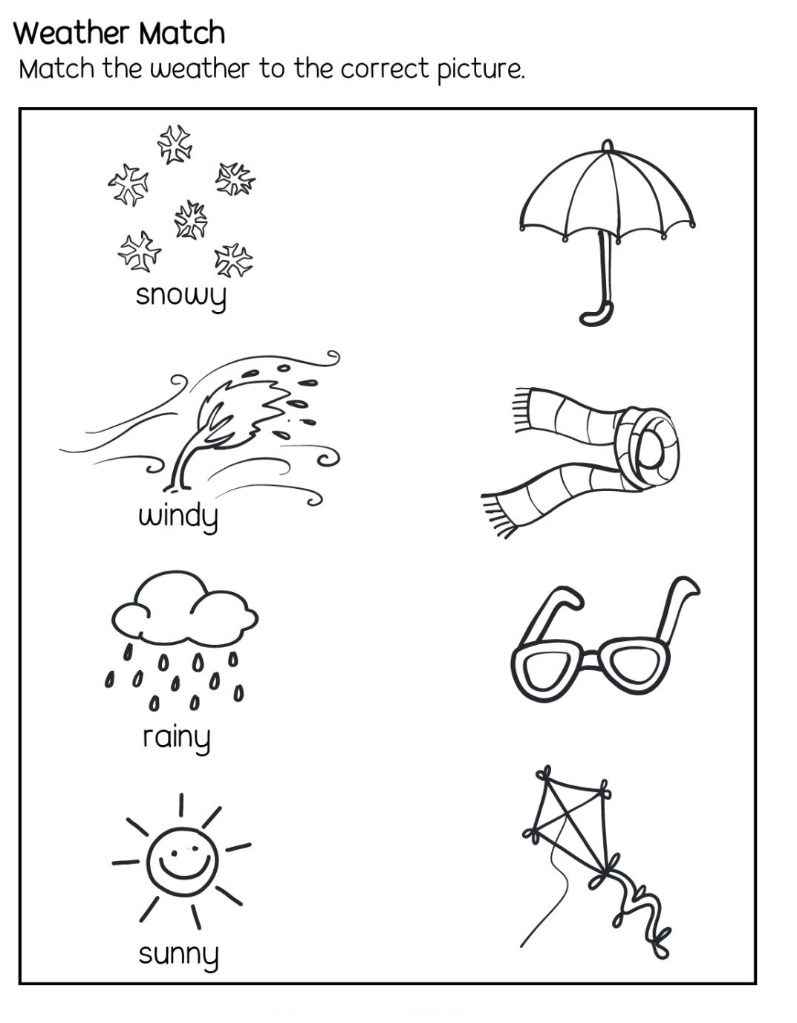

DISNEY KINDERGARTEN AND PRIMARY SCHOOL.
LITERACY HOLIDAY WORK- NURSERY CLASS..
Name: ______________________________________
What am I? Colour me.

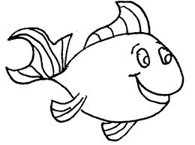

Colour me accordingly.
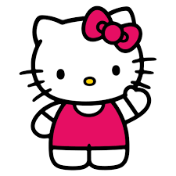

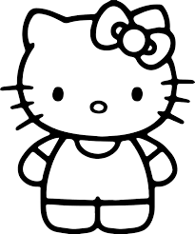

Colour only pictures that start with the given letter sounds.
a | 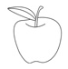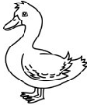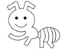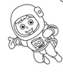
c | 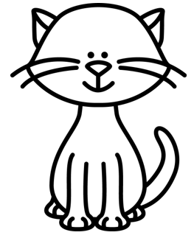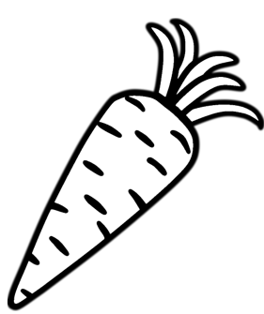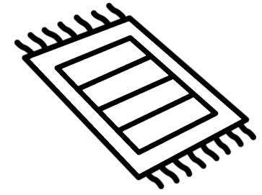
e | 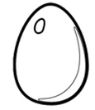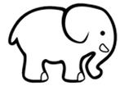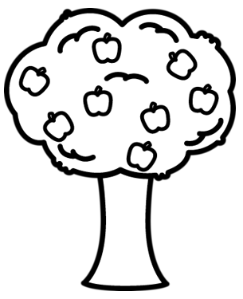
h | 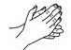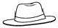
r | 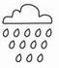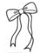
m | 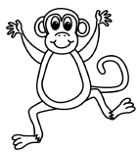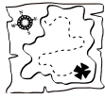
d | 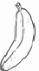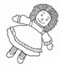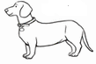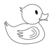

Form sound ‘a’ correctly.
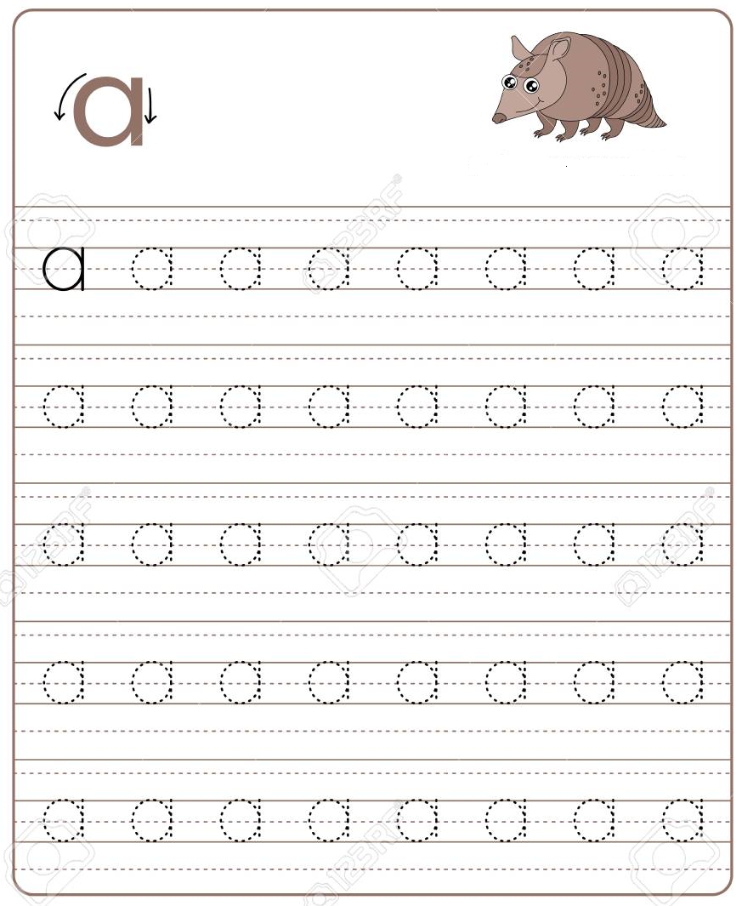

Form sound ‘c’ and colour the cake.


Form sound ‘e’ and colour the elephant.


Form sound ‘h’ and colour the hands.


Form sound ‘r’ and colour the rabbit.
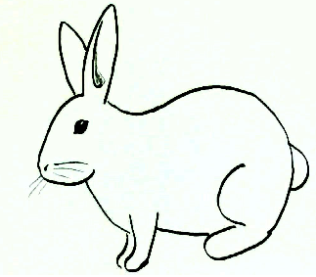


Form sound ‘m’ and colour the mat.
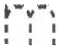

Form sound ‘d’ and colour the dress.
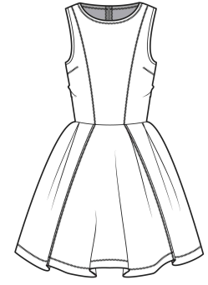


Draw the missing parts and colour the picture.
